DEEP LEARNING
Complete Notes for Deep Understanding
Every Term Explained • Clear Concepts • Detailed Examples
By
Dr. Mobeen Shahroz
Enhanced Edition with Figures and Visualizations

Table of Contents

Table of Contents 1
List of Figures 1
List of Tables 1
Purpose of This Document 1
SECTION 1: Introduction to Deep Learning 1
1.1 What is Deep Learning? 1
1.2 AI vs ML vs Deep Learning – The Hierarchy 1
1.3 Why Deep Learning Works Well (When It Does) 1
SECTION 2: Types of Deep Learning 1
2.1 Supervised Learning 1
2.2 Unsupervised Learning 1
2.3 Semi-Supervised Learning 1
2.4 Reinforcement Learning (RL) 1
SECTION 3: Neural Network Architectures 1
3.1 Feedforward Neural Networks (FNN / ANN) 1
3.2 Convolutional Neural Networks (CNN) 1
3.3 Recurrent Neural Networks (RNN) 1
3.4 Transformers 1
SECTION 4: The Neuron – The Fundamental Unit 1
4.1 Biological Inspiration 1
4.2 Mathematical Definition (Every Symbol Explained) 1
4.3 Worked Example 1
4.4 Why Activation Functions Matter – The Nonlinearity Requirement 1
SECTION 5: Forward Propagation 1
5.1 What is Forward Propagation? 1
5.2 Layer-by-Layer Calculation 1
5.3 Dimensions and Matrix Notation 1
SECTION 6: Loss Functions 1
6.1 What is a Loss Function? 1
6.2 Common Loss Functions 1
Mean Squared Error (MSE) – For Regression 1
Mean Absolute Error (MAE) – For Robust Regression 1
Binary Cross-Entropy – For Binary Classification 1
Categorical Cross-Entropy – For Multi-Class Classification 1
SECTION 7: Backpropagation – How Learning Happens 1
7.1 High-Level Intuition 1
7.2 Chain Rule Refresher 1
7.3 Backpropagation Step-by-Step 1
7.4 Weight Update – Gradient Descent 1
SECTION 8: Implementation Deep Dive 1
8.1 TensorFlow/Keras – Line-by-Line Explanation 1
Building a Model 1
Compiling the Model 1
Training the Model 1
8.2 PyTorch – Line-by-Line Explanation 1
Building a Model 1
Manual Training Loop 1
8.3 TensorFlow vs PyTorch – Deep Comparison 1
SECTION 9: Summary – Connecting Everything 1
9.1 The Complete Pipeline (Mental Model) 1
9.2 Key Takeaways 1
9.3 Recommended Learning Path 1
APPENDIX: Quick Reference – Every Term Defined 1

List of Figures

Figure 1: AI vs ML vs Deep Learning Hierarchy 12
Figure 2: Feedforward Neural Network (FNN) 18
Figure 3: Single Neuron – Step-by-Step Computation 22
Figure 4: Activation Functions Comparison (ReLU, Sigmoid, Tanh) 26
Figure 5: Backpropagation – The Learning Cycle 36
Figure 6: CNN Architecture – From Pixels to Classification 20
Figure 7: Simple RNN vs LSTM Memory Mechanism 21
Figure 8: Transformer Self-Attention Matrix 22
Figure 9: Loss Functions – What We Minimize During Training 32
Figure 10: Gradient Descent – Minimizing the Loss 37
Figure 11: Complete Deep Learning Pipeline 42
Figure 12: Supervised vs Unsupervised Learning 15

List of Tables

Table 1: Comparison of AI, ML, and Deep Learning 14
Table 2: Types of Deep Learning with Use Cases 17
Table 3: Neural Network Architectures Overview 23
Table 4: Activation Functions – Formula & When to Use 27
Table 5: Loss Functions – Formula & Application 33
Table 6: TensorFlow vs PyTorch Framework Comparison 40
Table 7: Quick Reference: Every Deep Learning Term Defined 44

Purpose of This Document
This comprehensive guide is designed to provide you with a deep understanding of deep learning concepts. It takes a learner-first approach by explaining every term before using it, showing intuition first and then mathematics, and then code. Concepts are connected step-by-step so nothing feels like an unexplained leap, and the document can be used as a standalone reference.

🎯 What Makes This Document Different
• Every technical term is defined before it is used
• Mathematical equations are explained symbol-by-symbol
• Worked numerical examples reinforce every concept
• Twelve original diagrams and visualizations
• Code examples in both TensorFlow/Keras and PyTorch
• Quick-reference tables and summary boxes throughout

SECTION 1: Introduction to Deep Learning

1.1 What is Deep Learning?
📖 Key Terms
Model – A mathematical system that learns to map inputs to outputs.
Learning – Automatically adjusting internal parameters based on data.
Layer – A collection of parallel computation units (neurons).
Hierarchical Representation – Building complex patterns from simple ones, layer by layer.

Deep learning is a subset of machine learning that uses many layers of nonlinear transformations. Each layer builds on the previous one to create increasingly abstract representations of the input data.
The word “deep” refers to having more than approximately three hidden layers, though modern networks can have 100 or more layers. Each layer automatically extracts progressively more complex features from the raw data.

Key Distinction: In traditional machine learning, you manually engineer features (e.g., extracting edges, shapes, or textures from images). In deep learning, the model discovers these features automatically from raw data through training. This is why deep learning excels on unstructured data such as images, audio, and text.

1.2 AI vs ML vs Deep Learning – The Hierarchy
Understanding how these three fields relate to each other is the first conceptual step. Each is a subset of the one above it:
- Artificial Intelligence (AI) – Any system that performs tasks normally requiring human intelligence, such as reasoning, perception, or decision-making.
- Machine Learning (ML) – A subset of AI where systems learn patterns from data without being explicitly programmed with fixed rules.
- Deep Learning (DL) – A subset of ML that uses deep neural networks (multiple stacked layers) to automatically learn hierarchical representations.

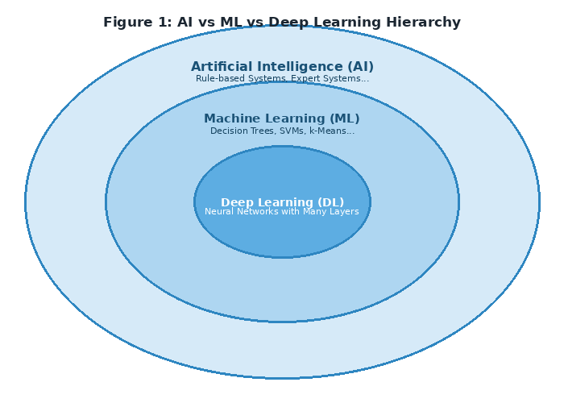
Figure 1: AI vs ML vs Deep Learning Hierarchy

Table 1: Comparison of AI, ML, and Deep Learning
Field | What it does | Typical Methods | Data Needed
Artificial Intelligence | Simulate human intelligence | Rule-based, search, planning | Any
Machine Learning | Learn patterns from data | Decision Trees, SVM, k-NN | Moderate
Deep Learning | Learn hierarchical features | Neural networks (CNN, RNN, Transformer) | Large (millions)

1.3 Why Deep Learning Works Well (When It Does)
Deep learning is not always the best tool. It thrives under specific conditions, and understanding these conditions helps you decide when to use it.
- Large-scale data – Deep learning typically needs millions of labeled examples to generalize well. With small datasets, simpler models like random forests often outperform neural networks.
- Unstructured data – Works exceptionally well with images, audio, text, and video, which have complex patterns that are difficult to engineer manually.
- Sufficient compute power – Requires GPUs (Graphics Processing Units) or TPUs (Tensor Processing Units) for practical training times. Training large models on CPUs alone would take weeks.
- Hierarchical structure – Problems that have a natural layered structure (pixels → edges → shapes → objects) are ideal.

Examples of Hierarchical Learning:
- Computer Vision: pixels → edges → textures → parts → objects → scenes
- Natural Language Processing: characters → words → phrases → sentences → meaning
- Audio Processing: waveforms → phonemes → words → sentences → intent

SECTION 2: Types of Deep Learning
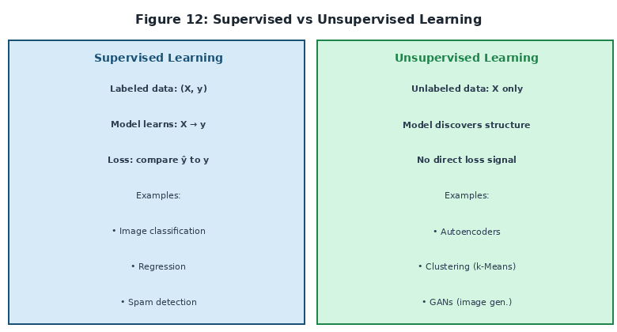
Figure 12: Supervised vs Unsupervised Learning

2.1 Supervised Learning
Definition: Training with input-output pairs (X, y) where y is the label — the correct answer provided by a human expert.
📊 Terms Explained
Label (y) – The correct answer we want the model to predict. E.g., "cat" or "dog" in image classification.
Loss Function – A mathematical function that measures how wrong the prediction is. Lower = better.
Training – The process of minimizing the loss over many labeled examples by adjusting the model's parameters.

Common Use Cases:
- Image classification (cat vs dog, handwritten digit recognition)
- Regression (predicting house prices, stock prices, temperatures)
- Speech recognition (converting audio waveforms to text)
- Sentiment analysis (classifying text as positive, negative, or neutral)

2.2 Unsupervised Learning
Definition: Training with only input data X — no labels are provided. The model must discover hidden structure or patterns entirely on its own.
What the model learns: patterns and structure, groupings or clusters of similar examples, compressed representations of the data, and anomalies or outliers.
- Autoencoders – Compress data to a small bottleneck representation, then reconstruct it. Learns efficient encoding.
- Generative Adversarial Networks (GANs) – A generator and discriminator compete, producing realistic new data samples.
- Contrastive Learning – Learn representations by comparing similar and dissimilar examples without labels.

2.3 Semi-Supervised Learning
Definition: Combines a small amount of labeled data with a large amount of unlabeled data. This is practical because labeling data is expensive and time-consuming.
Practical Example: Imagine you have 100 labeled medical images and 10,000 unlabeled ones. Semi-supervised learning uses the structure learned from 10,000 unlabeled images to dramatically improve the model trained on only 100 labeled ones.

2.4 Reinforcement Learning (RL)
Definition: Learning through trial and error by receiving rewards for good actions and penalties for bad actions. There is no fixed dataset — the model (agent) generates experience by interacting with an environment.
🎮 Key RL Terms
Agent – The learner or decision-maker (e.g., a robot, a game-playing program).
Environment – The world the agent interacts with (e.g., a chessboard, a physical robot arm).
Action – What the agent decides to do at each time step.
Reward – Feedback signal (+1 for good, -1 for bad) indicating how good the action was.
Policy – The learned strategy: given state S, take action A.

Deep RL combines deep neural networks with RL, allowing agents to handle high-dimensional inputs like raw images. Famous examples: AlphaGo (board games), OpenAI Five (Dota 2), autonomous driving.

Table 2: Types of Deep Learning with Use Cases
Type | Data Available | What Model Learns | Example Applications
Supervised | Labeled (X, y) | Input → Output mapping | Image classification, Regression, NLP
Unsupervised | Unlabeled (X only) | Hidden structure, patterns | Autoencoders, GANs, Clustering
Semi-supervised | Mostly unlabeled | Structure + task labels | Medical imaging, Text classification
Reinforcement | Rewards from environment | Optimal decision policy | Games, Robotics, Autonomous driving

SECTION 3: Neural Network Architectures
Table 3: Neural Network Architectures Overview
Architecture | Best For | Key Mechanism | Example Uses
FNN / MLP | Tabular / structured data | Fully connected layers | Fraud detection, churn prediction
CNN | Images, spatial data | Convolutional filters + pooling | Image classification, object detection
RNN / LSTM | Sequences, time series | Hidden state memory | Text generation, speech recognition
Transformer | Long sequences, language | Self-attention mechanism | GPT, BERT, machine translation

3.1 Feedforward Neural Networks (FNN / ANN)
Definition: Information flows forward only — no cycles or feedback loops. Data passes from input → hidden layers → output in one direction only. Also called a Multi-Layer Perceptron (MLP).
When to use: Tabular data (spreadsheets, databases), non-sequential data where each example is independent, and fixed-size input with the same number of features per example.

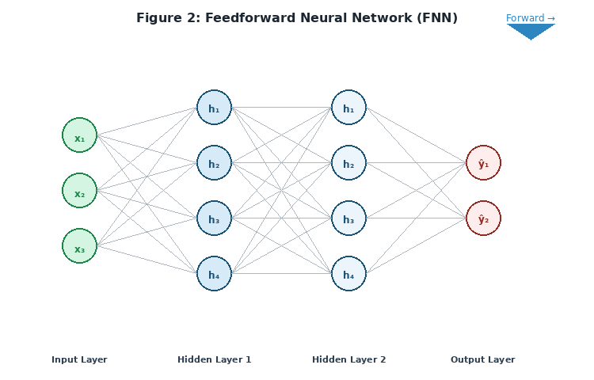
Figure 2: Feedforward Neural Network (FNN) — Information flows left to right

3.2 Convolutional Neural Networks (CNN)
Intuition: Slide a small window (called a filter or kernel) across the input image to detect patterns wherever they appear. The same filter is reused across the entire image, so a pattern learned in one location can be recognized anywhere — this property is called translational equivariance.
🔍 CNN Key Terms
Convolution – Element-wise multiplication between the filter and an input patch, then summing the results into a single value.
Filter/Kernel – A small learnable weight matrix (e.g., 3×3, 5×5) that detects specific patterns like edges or curves.
Feature Map – The output tensor after applying a filter across the entire input. Each filter produces one feature map.
Pooling – Downsampling (max or average) that reduces spatial dimensions while retaining important features.
Receptive Field – The region of the original input that influences a particular neuron's output.

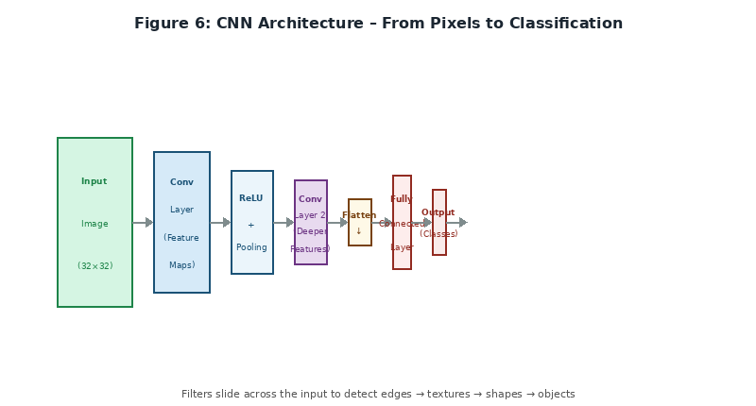
Figure 6: CNN Architecture — From Pixels to Classification

3.3 Recurrent Neural Networks (RNN)
Intuition: Has memory — the output at each time step depends on both the current input and the previous hidden state. This allows the network to maintain context over sequences of arbitrary length.
Problem — Vanishing Gradient: During training, gradients must flow backward through time. For long sequences, gradients become exponentially smaller (vanish), preventing learning of long-range dependencies.
Improved Variants:
- LSTM (Long Short-Term Memory) – Uses three gates (Forget, Input, Output) to control which information is stored, updated, and passed forward. Solves the vanishing gradient problem.
- GRU (Gated Recurrent Unit) – Simplified version of LSTM with two gates and fewer parameters, offering similar performance.

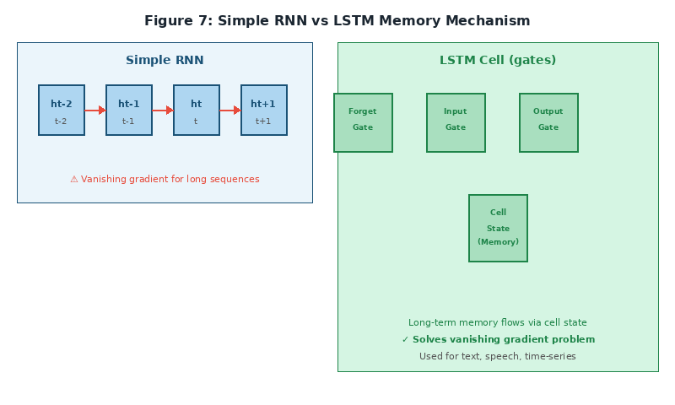
Figure 7: Simple RNN vs LSTM — How Gates Solve the Vanishing Gradient Problem

3.4 Transformers
Intuition: No recurrence at all. Instead, uses attention mechanisms to look at all positions in a sequence simultaneously. Every token (word, pixel patch) attends to every other token, making the model fully parallelizable and capable of capturing long-range dependencies in a single layer.
✨ Transformer Key Terms
Self-Attention – Each token computes how much it should attend to every other token. The result is a weighted sum of values.
Query, Key, Value (Q, K, V) – Three learned projections of the input. Attention score = softmax(Q·Kᵀ / √d).
Positional Encoding – Since there is no recurrence, position information is explicitly added to each token embedding.
Multi-Head Attention – Running attention h times in parallel (different W_Q, W_K, W_V per head), allowing the model to attend to different aspects simultaneously.

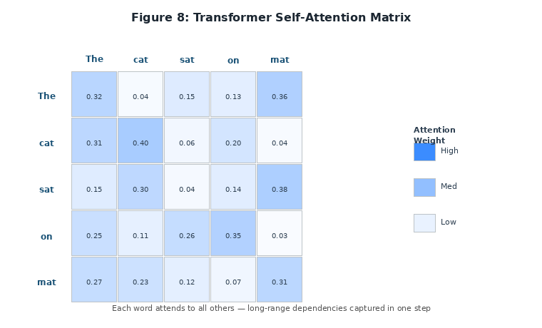
Figure 8: Transformer Self-Attention Matrix — Each Word Attends to All Others

SECTION 4: The Neuron – The Fundamental Unit

4.1 Biological Inspiration
Artificial neurons are a simplified mathematical model inspired by biological neurons in the human brain. The analogies are approximate but helpful for building intuition:
Biological Neuron | Artificial Neuron | Role
Dendrites | Input values (xᵢ) | Receive incoming signals
Synaptic strength | Weights (wᵢ) | Determine importance of each input
Cell body | Weighted sum + bias (z) | Integrate all signals
Action potential threshold | Activation function f(z) | Decide whether to fire (output)
Axon | Output activation (a) | Transmit result to next layer

4.2 Mathematical Definition (Every Symbol Explained)
A neuron performs exactly two operations in sequence:
- Weighted sum plus bias (pre-activation): z = (w₁·x₁ + w₂·x₂ + … + wₙ·xₙ) + b
- Apply activation function: a = f(z)

📝 Every Symbol Defined
xᵢ – Input value from the previous layer or raw data. The subscript i identifies which input.
wᵢ – Weight for input xᵢ. Determines how much influence that input has. Learned during training.
b – Bias term. Shifts the activation threshold, allowing the neuron to fire even when all inputs are zero.
z – Pre-activation: the raw weighted sum before applying the activation function.
f – Activation function (e.g., ReLU, Sigmoid). Introduces nonlinearity — without it, the entire network collapses to a single linear transformation regardless of depth.
a – Activation: the neuron's output, passed to the next layer.

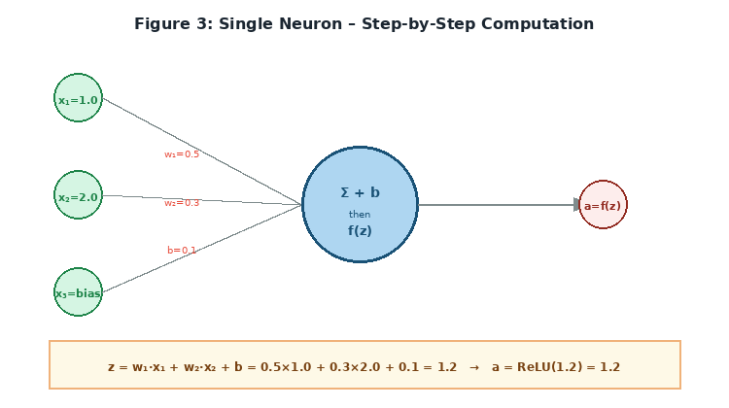
Figure 3: Single Neuron – Step-by-Step Computation with Example Numbers

4.3 Worked Example
Given: Inputs x₁ = 1.0, x₂ = 2.0. Weights w₁ = 0.5, w₂ = 0.3. Bias b = 0.1. Activation: ReLU.
Step 1 (Weighted sum): z = (0.5 × 1.0) + (0.3 × 2.0) + 0.1
z = 0.5 + 0.6 + 0.1 = 1.2
Step 2 (Activation): a = ReLU(1.2) = max(0, 1.2) = 1.2
Interpretation: The neuron received inputs with a combined weighted influence of 1.2, and since this is positive, ReLU lets it pass unchanged. A negative z would have been clamped to 0.

4.4 Why Activation Functions Matter – The Nonlinearity Requirement
Without activation functions (or with only linear activations), a network with 100 layers is mathematically equivalent to a single linear transformation. Nonlinear activations allow the network to represent complex, curved decision boundaries.

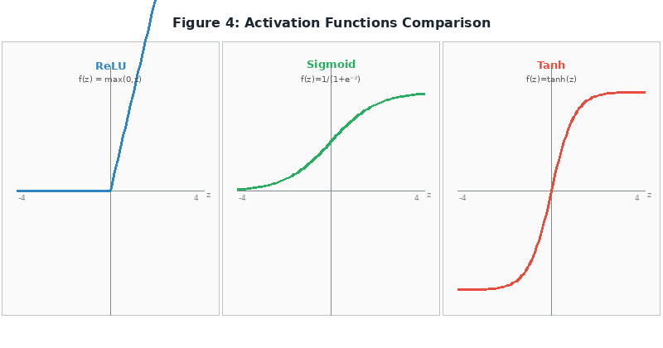
Figure 4: Activation Functions Comparison — ReLU, Sigmoid, and Tanh

Table 4: Activation Functions – Formula & When to Use
Function | Formula | Output Range | Best Used For | Key Property
ReLU | max(0, z) | [0, ∞) | Hidden layers (default choice) | Fast, sparse, solves vanishing gradient
Sigmoid | σ(z) = 1/(1+e⁻ᶣ) | (0, 1) | Binary output layer | Outputs probability; saturates at extremes
Tanh | tanh(z) | (-1, 1) | Hidden layers (when centering helps) | Zero-centered; better gradient flow than sigmoid
Softmax | eˢᵢ / Σeˢⱼ | (0,1), sums to 1 | Multi-class output layer | Produces probability distribution
Leaky ReLU | max(0.01z, z) | (-∞, ∞) | Hidden layers (avoids dead neurons) | Allows small gradient for z < 0

SECTION 5: Forward Propagation

5.1 What is Forward Propagation?
Forward propagation is the process of computing a prediction by passing input data through every layer of the network from left (input) to right (output). No learning happens yet — this is purely the computational pass that produces ŷ (y-hat, the predicted output).

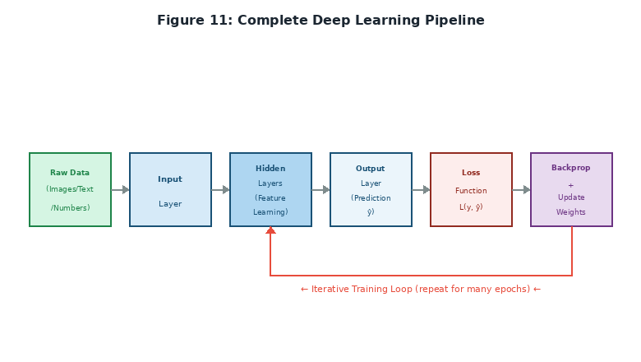
Figure 11: Complete Deep Learning Pipeline — Forward and Backward Passes

5.2 Layer-by-Layer Calculation
For a network with Input Layer → Hidden Layer 1 → Hidden Layer 2 → Output Layer:
Hidden Layer 1: z₁ = W₁ · x + b₁ → a₁ = ReLU(z₁)
Hidden Layer 2: z₂ = W₂ · a₁ + b₂ → a₂ = ReLU(z₂)
Output Layer: z₃ = W₃ · a₂ + b₃ → ŷ = Softmax(z₃)

Each W is a weight matrix and each b is a bias vector. During forward propagation, W and b are fixed (not updated). They are only updated during backpropagation.

5.3 Dimensions and Matrix Notation
In practice, we process many examples simultaneously in a batch using matrix operations. If we have a batch of 32 examples each with 10 features:
- Input X has shape (32, 10) — 32 rows (examples), 10 columns (features)
- Weight matrix W₁ for a 64-neuron hidden layer has shape (10, 64)
- Bias vector b₁ has shape (64,) — one bias per neuron
- Output Z₁ = X · W₁ + b₁ has shape (32, 64) — 32 examples, 64 activations each

SECTION 6: Loss Functions

6.1 What is a Loss Function?
A loss function (also called a cost function or objective function) measures how wrong the model's predictions are compared to the true labels. It produces a single number — the loss — that the training process tries to minimize.
Without a loss function: there is no objective to optimize, no way to measure improvement, and no way to adjust weights. The loss function is the bridge between model predictions and the learning algorithm.

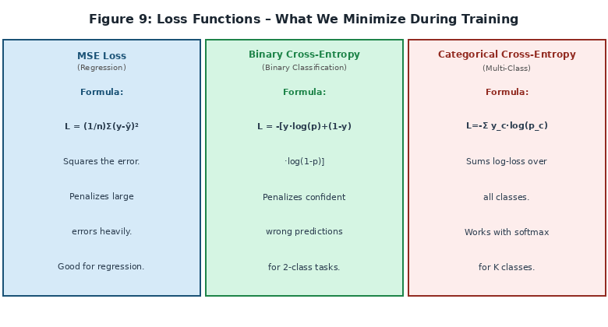
Figure 9: Loss Functions — What We Minimize During Training

6.2 Common Loss Functions

Mean Squared Error (MSE) – For Regression
MSE = (1/n) × Σ(y_true - y_pred)²
MSE squares the error, so large errors are penalized much more than small ones. Ideal when large prediction errors are especially costly. Use for: house price prediction, temperature forecasting, any continuous output.

Mean Absolute Error (MAE) – For Robust Regression
MAE = (1/n) × Σ |y_true - y_pred|
Uses absolute value instead of squaring. Less sensitive to outliers than MSE because it does not disproportionately penalize large errors. Gradient is not smooth (not differentiable at 0), but Huber loss solves this.

Binary Cross-Entropy – For Binary Classification
BCE = -(1/n) Σ [y_true · log(y_pred) + (1-y_true) · log(1-y_pred)]
Heavily penalizes confident wrong predictions. If the true label is 1 but the model predicts 0.01 (nearly certain it is 0), the penalty is enormous — -log(0.01) ≈ 4.6. Use for: spam detection, fraud detection, disease diagnosis.

Categorical Cross-Entropy – For Multi-Class Classification
CCE = -(1/n) Σᵢ Σ_c [y_true_c · log(y_pred_c)]
Generalization of BCE for K classes. Works with a softmax output layer that produces a probability distribution over all classes. Use for: digit recognition (0–9), image classification with many categories, language modeling.

Table 5: Loss Functions – Formula & Application
Loss Function | Formula (simplified) | Task Type | Key Property
MSE | mean((y - ŷ)²) | Regression | Penalizes large errors heavily
MAE | mean(|y - ŷ|) | Robust regression | Less sensitive to outliers
Binary Cross-Entropy | -mean(y·log(p)+(1-y)·log(1-p)) | Binary classification | Penalizes confident wrong predictions
Categorical Cross-Entropy | -mean(Σ y_c·log(p_c)) | Multi-class classification | Works with softmax probability output
Huber Loss | MSE for small errors, MAE for large | Regression with outliers | Smooth + robust combination

SECTION 7: Backpropagation – How Learning Happens

7.1 High-Level Intuition
The central question of backpropagation is: how does changing a weight in an early layer affect the final loss? The answer uses the chain rule from calculus to trace the effect of each weight backward through the network, layer by layer.
🚗 Analogy: Steering a Car
You turn the steering wheel (change a weight in layer 1)
This affects the front wheels (output of layer 1 changes)
Which affects the car's direction (layer 2, layer 3, ...)
Which affects how far you are from the target (final loss)
Backpropagation computes exactly how much EACH weight contributed to the error.

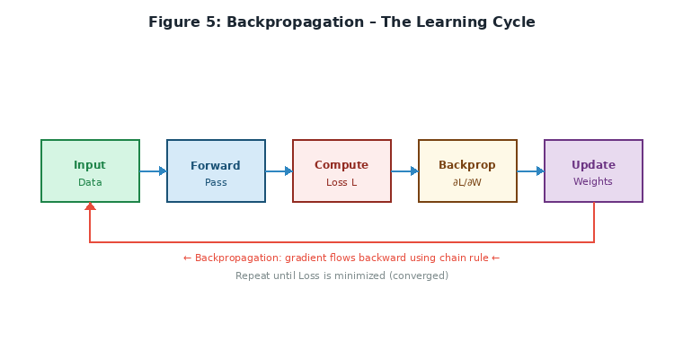
Figure 5: Backpropagation – The Learning Cycle

7.2 Chain Rule Refresher
Backpropagation relies on one rule from calculus — the chain rule. If Loss L depends on output y, and y depends on weight w:
∂L/∂w = (∂L/∂y) × (∂y/∂w)
In words: how much does the loss change when w changes = (how much does L change when y changes) times (how much does y change when w changes). For deep networks, we chain multiple derivatives together across all layers.

7.3 Backpropagation Step-by-Step
Working backward from the output layer to the input layer, for each layer:
- Compute gradient of loss with respect to layer output: ∂L/∂a
- Compute gradient w.r.t. pre-activation: ∂L/∂z = ∂L/∂a × f'(z) [activation gradient]
- Compute gradient w.r.t. weights and biases: ∂L/∂W = ∂L/∂z × a_prevᵀ
- Compute gradient w.r.t. input to this layer: ∂L/∂a_prev = Wᵀ × ∂L/∂z [passed to previous layer]

7.4 Weight Update – Gradient Descent
Once we have the gradients, we update every weight:
w_new = w_old - η × (∂L/∂w)
📌 Every Symbol Explained
w_old – Current weight value before this update step.
η (eta) – Learning rate: controls the step size. Typical values: 0.001 to 0.1.
∂L/∂w – Gradient: tells us the direction and magnitude of change needed. Points uphill.
Minus sign – We subtract because the gradient points toward higher loss. We want to go downhill.
w_new – Updated weight value after this step.

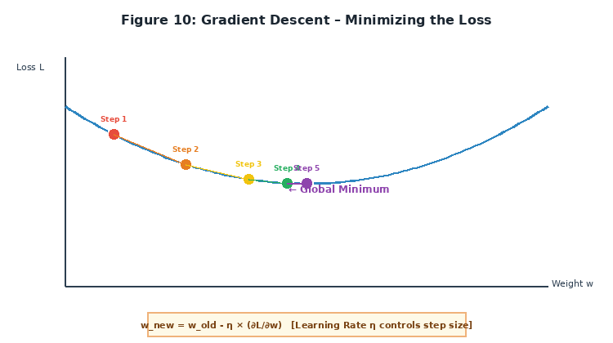
Figure 10: Gradient Descent – Following the Slope Downhill to Minimize Loss

Learning Rate Trade-offs: A learning rate that is too small leads to very slow training and risk of getting stuck in local minima. Too large leads to unstable training that overshoots the minimum and may diverge. The right learning rate provides steady, reliable convergence.

SECTION 8: Implementation Deep Dive

8.1 TensorFlow/Keras – Line-by-Line Explanation

Building a Model
import tensorflow as tf
from tensorflow.keras import layers

model = tf.keras.Sequential([
layers.Dense(10, activation='relu', input_shape=(2,)),
layers.Dense(1)
])

💬 Line-by-Line Explanation
tf.keras.Sequential – Layers are stacked linearly; output of one feeds into the next.
layers.Dense(10, activation='relu') – Fully connected layer with 10 neurons and ReLU activation.
input_shape=(2,) – Tells the model to expect inputs with exactly 2 features per sample.
layers.Dense(1) – Output layer with 1 neuron and linear activation (for regression).

Compiling the Model
model.compile(
optimizer='adam',
loss='mse',
metrics=['mae']
)

💬 Compile Explained
optimizer='adam' – Adam (Adaptive Moment Estimation) adjusts the learning rate per parameter. Combines SGD with momentum and RMSprop.
loss='mse' – Mean squared error; used for regression tasks.
metrics=['mae'] – Tracks mean absolute error during training for human-readable progress monitoring.

Training the Model
history = model.fit(
X_train, y_train,
epochs=100,
batch_size=32,
validation_split=0.2,
verbose=1
)

💬 Training Parameters Explained
epochs=100 – Number of complete passes through the entire training dataset.
batch_size=32 – Number of samples processed before updating the weights once. Larger batches = more stable gradients but more memory.
validation_split=0.2 – Reserve 20% of training data for validation to monitor for overfitting.
verbose=1 – Print a progress bar with loss and metrics after each epoch.

8.2 PyTorch – Line-by-Line Explanation

Building a Model
import torch
import torch.nn as nn
import torch.optim as optim

model = nn.Sequential(
nn.Linear(2, 10), # input_size=2, output_size=10
nn.ReLU(),
nn.Linear(10, 1) # output layer
)

Manual Training Loop
criterion = nn.MSELoss()
optimizer = optim.Adam(model.parameters(), lr=0.001)

for epoch in range(100):
predictions = model(X_train) # Forward pass
loss = criterion(predictions, y_train) # Compute loss

optimizer.zero_grad() # Clear old gradients (CRITICAL!)
loss.backward() # Backpropagation: compute all gradients
optimizer.step() # Update all weights: w -= lr * gradient

⚠ Critical Steps Explained
optimizer.zero_grad() – PyTorch accumulates gradients by default. You MUST clear them before each backward pass, or gradients from previous batches will corrupt the update.
loss.backward() – Triggers backpropagation. Computes ∂L/∂w for every parameter in the model via the chain rule.
optimizer.step() – Updates all parameters: w = w - lr × gradient.
This three-step pattern (zero_grad → backward → step) is fundamental to all PyTorch training.

8.3 TensorFlow vs PyTorch – Deep Comparison
Table 6: TensorFlow vs PyTorch Framework Comparison
Aspect | TensorFlow (Keras) | PyTorch
Philosophy | High-level, batteries-included | Low-level, explicit control
Training Loop | Automated (model.fit handles everything) | Manual (you write every step)
Debugging | Harder (graph execution by default) | Easier (eager execution, fully Pythonic)
Research use | Good | Excellent (preferred by researchers)
Production deployment | Excellent (TF Serving, TF Lite, TFJS) | Good (TorchServe, ONNX export)
Learning curve | Gentler — quick to get first model running | Steeper initially, deeper understanding
Community | Strong industry adoption | Dominant in academia and research

🎯 Which Framework to Learn First?
Start with TensorFlow/Keras if you want quick wins, high-level abstractions, and deployment focus.
Learn PyTorch for deeper understanding, research, and custom architectures.
Eventually learn both — they are complementary. Knowing both makes you more versatile and employable.

SECTION 9: Summary – Connecting Everything

9.1 The Complete Pipeline (Mental Model)
Raw Data
↓
Input Layer (no computation, just receives data)
↓
Hidden Layer 1: z₁ = W₁·x + b₁ → ReLU → a₁
↓
Hidden Layer 2: z₂ = W₂·a₁ + b₂ → ReLU → a₂
↓
Output Layer: z₃ = W₃·a₂ + b₃ → activation → ŷ
↓
Loss: L(y_true, ŷ) [measure prediction error]
↓
Backpropagation: compute ∂L/∂W₃, ∂L/∂W₂, ∂L/∂W₁
↓
Update: W_new = W_old - η · gradient
↓
Repeat until loss is acceptably low (convergence)

9.2 Key Takeaways
- Deep learning = hierarchical feature learning through many nonlinear layers. Each layer extracts increasingly abstract features automatically.
- Neuron = weighted sum + bias + activation. Simple but powerful. The activation function provides the nonlinearity that makes deep networks expressive.
- Forward propagation = computing predictions. Data flows from input through all layers to the output in one direction.
- Loss = error measurement. The objective function we minimize during training provides the signal for learning.
- Backpropagation = efficient gradient computation via the chain rule. Calculates how each weight affects the final loss.
- Gradient descent = weight update rule. We move weights in the direction that reduces loss by subtracting the gradient scaled by the learning rate.
- Frameworks (TensorFlow/PyTorch) implement automatic differentiation (autograd), handling all derivative calculations for you.

9.3 Recommended Learning Path
- Implement a single neuron from scratch in NumPy (no frameworks) to truly understand the mechanics.
- Implement forward + backward propagation for one layer manually to see backprop in action.
- Build a small network on a simple dataset such as XOR or a 2D classification problem.
- Switch to TensorFlow/Keras for practical projects and leverage efficient implementations.
- Study specialized architectures: CNNs for images, RNNs/Transformers for sequences.
- Practice on real datasets: Kaggle competitions, MNIST, CIFAR-10.
- Learn advanced topics: regularization (Dropout, L2), optimization algorithms (Adam, RMSprop), hyperparameter tuning.

APPENDIX: Quick Reference – Every Term Defined
Table 7: Quick Reference: Every Deep Learning Term Defined
Term | Definition
Neuron | Weighted sum + bias + activation function
Weight | Learned parameter determining importance of an input
Bias | Learned parameter that shifts the activation threshold
Activation Function | Nonlinear function enabling complex pattern learning
Layer | Collection of neurons processing data in parallel
Deep | Having many layers (typically > 3 hidden layers)
Forward Propagation | Computing output by passing data through layers
Loss | Measurement of prediction error
Backpropagation | Computing gradients via chain rule, layer by layer
Gradient Descent | Updating weights to minimize loss
Learning Rate (η) | Step size for weight updates (typically 0.001–0.1)
Epoch | One complete pass through the entire training dataset
Batch | Subset of data processed before updating weights
Mini-batch SGD | Stochastic gradient descent on small batches (32–256)
Dense Layer | Fully connected: every neuron connects to all previous neurons
ReLU | Rectified Linear Unit: max(0, z) — default activation
Sigmoid | S-shaped function: 1/(1+e⁻ᶣ), outputs 0 to 1 (probability)
Softmax | Converts logits to probability distribution across K classes
CNN | Convolutional Neural Network for spatial / image data
RNN | Recurrent Neural Network with hidden state memory for sequences
LSTM | Long Short-Term Memory: solves vanishing gradient with gates
Transformer | Architecture using self-attention for sequences and vision
Overfitting | Model memorizes training data, fails to generalize to new data
Regularization | Techniques to prevent overfitting (Dropout, L1, L2)
Dropout | Randomly deactivate neurons during training to prevent co-adaptation
Optimizer | Algorithm for updating weights (Adam, SGD, RMSprop)
Gradient | Partial derivative indicating direction + magnitude to reduce loss
Autograd | Automatic differentiation: frameworks compute gradients automatically
Hyperparameter | Configuration set before training (lr, layers, batch size)
Validation Set | Held-out data used to monitor overfitting during training

This document provides complete, self-contained notes explaining every term before using it, showing mathematics step-by-step, and connecting theory to code. It now includes twelve original visualizations to reinforce every key concept.

— End of Document —

